1. In My Profile, the user is not able to add text in text fields like Agency Name, Name, and Pin Code etc.

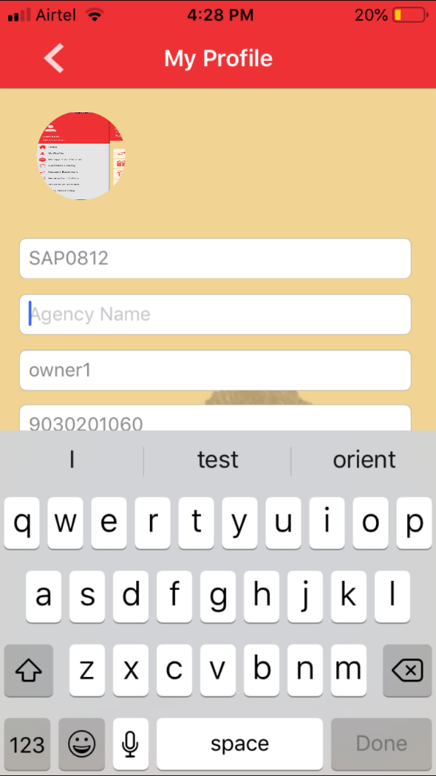

1. **My Profile -> District:** The blank space is showing displaying in District, state, city Page. Then on scrolling, it is showing list of districts. Please check

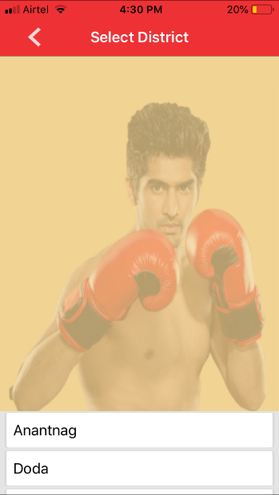

1. **Values are not getting populated in my profile. Data is truncating in view profile.**
2. **My Profile:** I have updated the profile image of dealer, but the updated image is not reflecting in left menu bar as well as on the home page. In My Profile only the image is showing
3. **Alignment of text is not proper on dashboard**

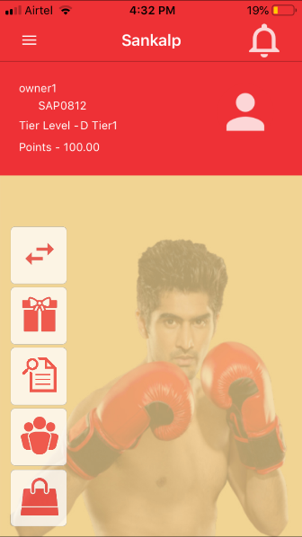

1. **Store Advertising:** It is showing Coming Soon popup on clicking Select Campaign Type drop-down.

On clicking OK, it is going back to Store Advertising Page

Also, Campaign Type is showing list of invalid campaigns

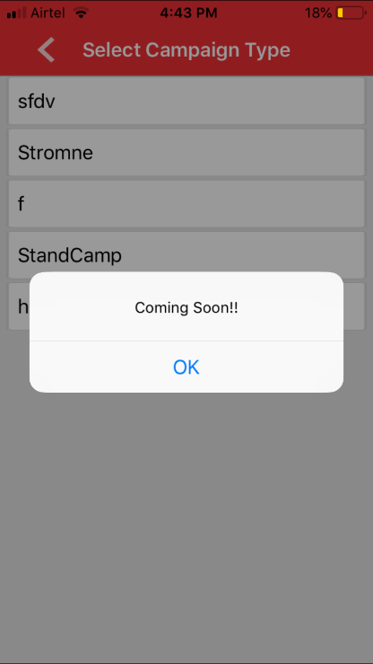

1. **View Member:** The menu icon is not working properly. On clicking center of the Member information page, it is showing menu. Ideally, the menu bar should also get expanded on clicking the icon

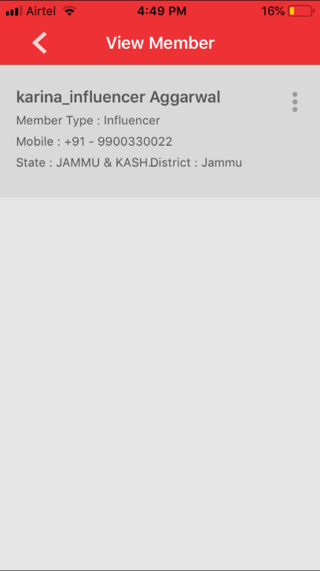

1. Please check for the overlapping of text.

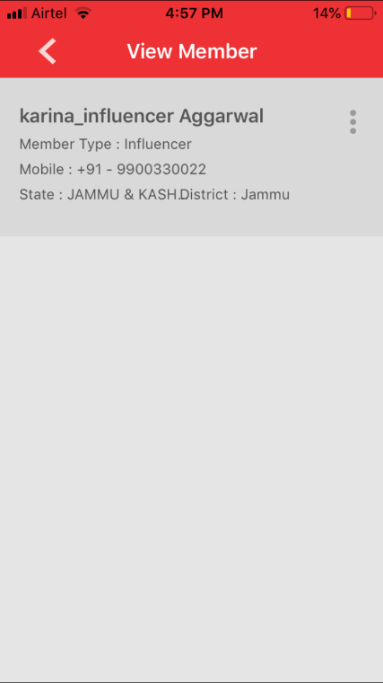

1. **Manage Your Member -> Update Member’s Profile:** The user is not able to submit OTP as the text box is not getting hidden on clicking done

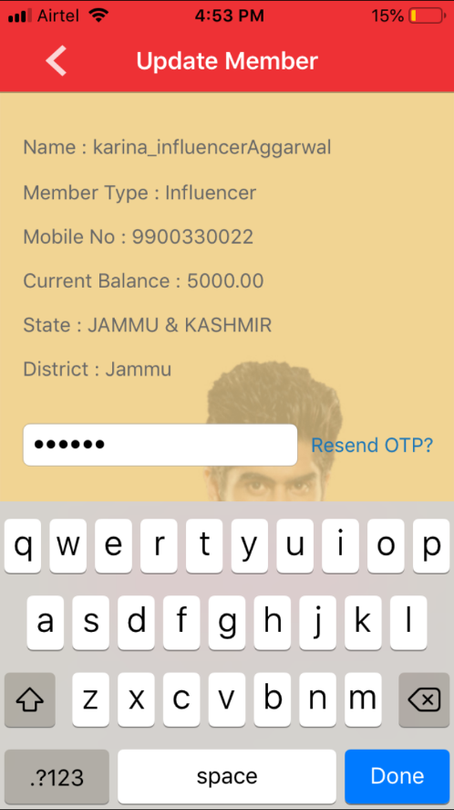

1. **Manage Your Member:** Balance is not showing in Add Transaction Page. Value is passed in API but not showing up so not to be considered as extra effort.

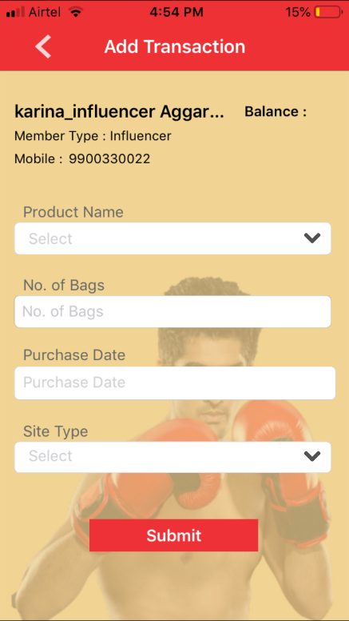

# Vijeta

Top bar colour should match with theme colour.

1. **Manage Your Member -> Add Transaction:** On clicking Back Button from Select Product Page, it should direct to the Member Details page or Add Transaction page. Rather it is directing to the home page right now.
2. My Profile: Profile Image is not getting updated. As Profile picture option is not clickable.

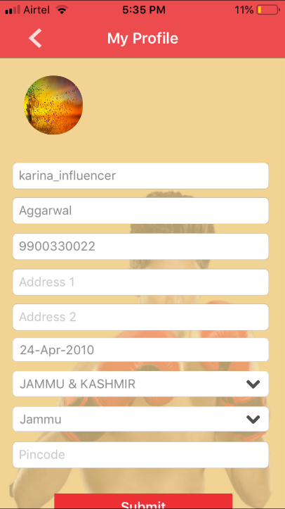

1. My Profile: Please check the text is truncating

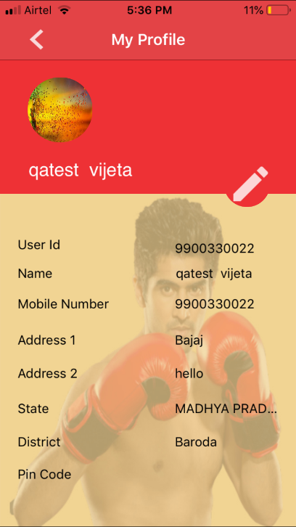

1. My Profile: Pin Code is not getting updated. But same is passed in API, so not be considered as extra effort.

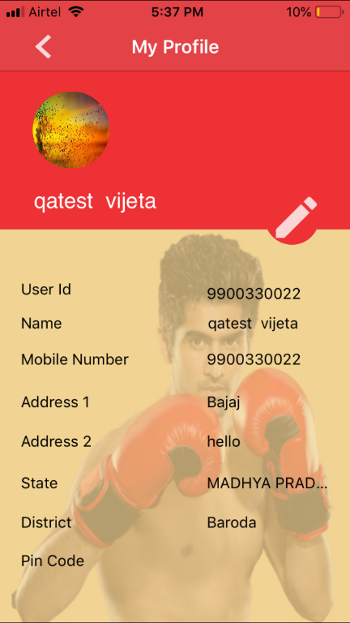

1. Redemption History: The header should be “Redemption History” not reference history

